IGRA CA2 Document (Lilypad Jump)

By: Ryan Tan Rui Ann 1829105, Brandon Gui 1828865 (from DIT/FT/2B/05)

# Instructions

**Controls:**

A - Jump left

D - Jump tight

Left Click - Clear Obstacle

**Objective:**

Jump to the last lilypad without falling into the water or hitting an obstacle before the timer runs out.

# Game Concept

The player plays as a duck jumping on lily pads. The lily pads have obstacles on them in which the player has to click on them to clear the way for the duck to jump on those lily pads. The duck has to reach the last lily pad within a certain amount of time to win the game.

The duck is controlled using the A and D key, in which the player would jump left and right down a perspective plane. The player clicks on obstacles to get rid of them.

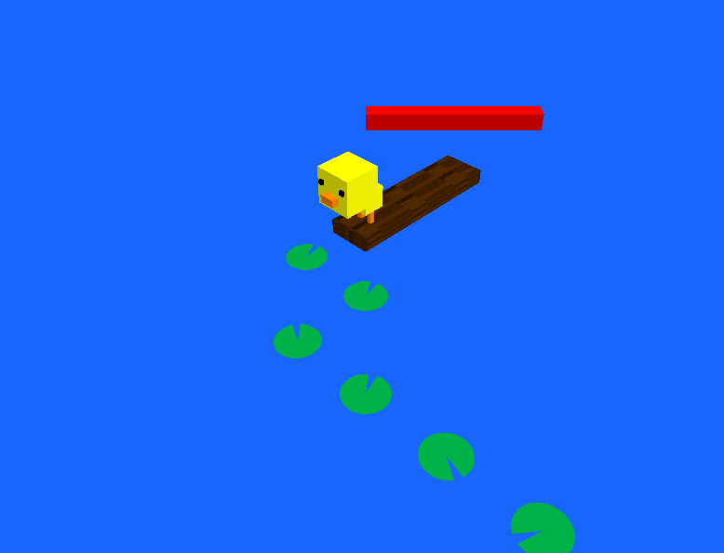

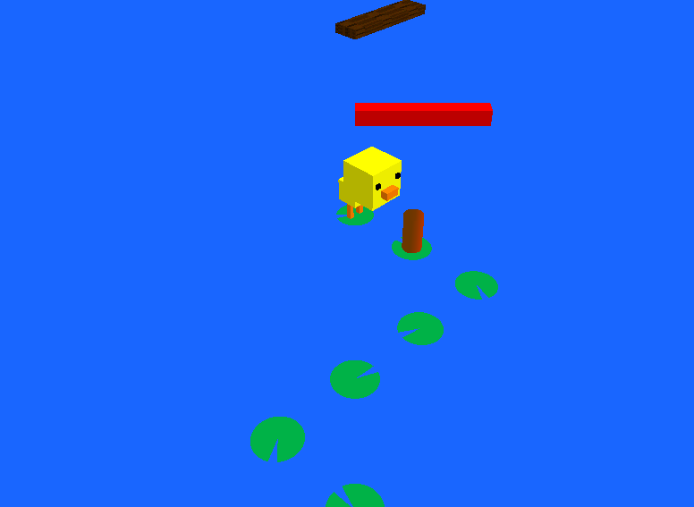

*Duck on the starting Log of the game*

## 